Ideation Phase
Brainstorm & Idea Prioritization

Date | 30 September 2026
Team ID | SWTID-2026-8455
Project Name | AI - FAQ ASSISTANT
Maximum Marks | 4 Marks

Brainstorm & Idea Prioritization
Brainstorming and idea prioritization is a structured process that helps a team identify problems, generate creative solutions, and select the most suitable ideas. The process begins by clearly defining the problem and understanding the needs of users and stakeholders. Team members then brainstorm ideas freely without immediate judgment, encouraging creativity and different perspectives. Similar ideas are grouped into meaningful themes to make them easier to analyse. The ideas are then evaluated based on factors such as impact, effort, feasibility, and value. Finally, the highest-priority ideas are selected, refined into a clear solution, and converted into actionable next steps for further development.

Step-1: Team Gathering, Collaboration and Select the Problem Statement
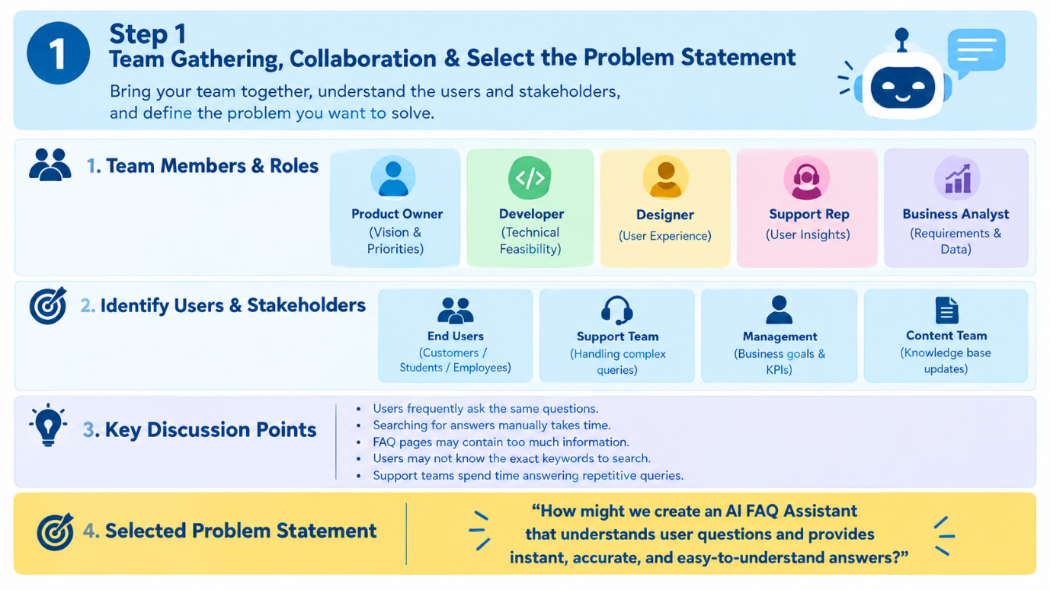

Step-2: Brainstorm, Idea Listing and Grouping
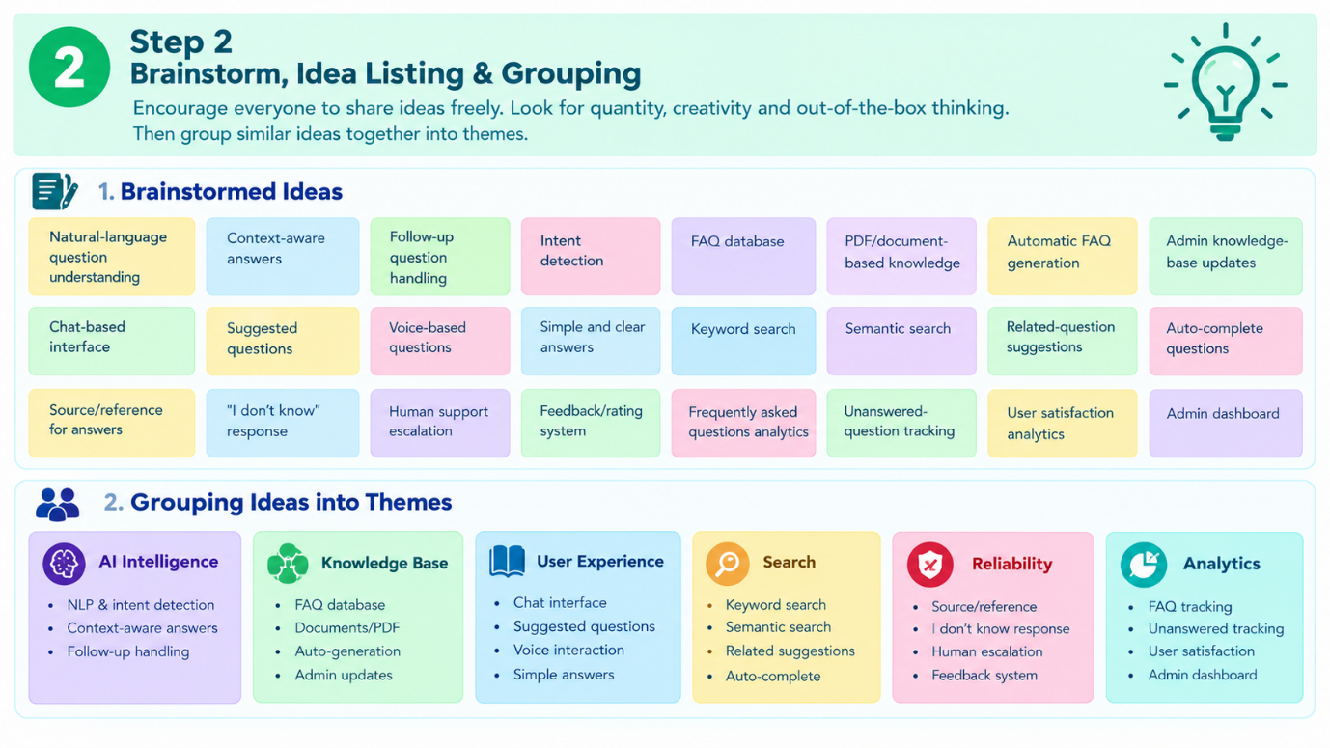

Step-3: Idea Prioritization
